HD 181433

HD 181433 is a 0.78 M☉, K5 V star1. Based on 107 RV HARPS data obtained between 2003 and 2008, a study performed in 2009 (hereafter B09)1 reported a Hot Jupiter (HD 181433b) signal with a period of 9.3743 ± 0.0019 days, a minimum mass of 0.024 MJup and an eccentricity of 0.396 ± 0.062, a GP (HD 181433c) signal with a period of 962 ± 15 days, a minimum mass of 0.64 MJup and an eccentricity of 0.28 ± 0.02 as well as a LPGP (HD 181433d) with a period of 2172 ± 158 days, a minimum mass of 0.54 MJup and an eccentricity of 0.48 ± 0.05. The CH survey reported properties close to those reported in the B09 study for planets b and c; conversely, they reported a period of 3201 days, a minimum mass of 0.58 MJup and an eccentricity of 0.11 for HD 181433d. Based in 36 additional RV measurements obtained with HARPS obtained between 2008 and 2017, a study performed in 2019 (hereafter H19)2 reported properties of planets b and c close to those reported in the B09 study and a period of 7012 ± 276 days, a minimum mass of 0.612 ± 0.004 MJup and an eccentricity of 0.469 ± 0.013 for HD 181433d.

In this study, the H19's dataset was used. DPASS and MCMC (1000 walkers and 400000 iterations) were used to fit the data. To converge more easily, the priors on the semi-major axis and the minimum mass of HD 181433b were close to the values found by the H19 study. The properties found for the planets b and c are close to those reported in the H19 study. For HD 181433d, a period of 6847 days, a minimum mass of 0.6 MJup and an eccentricity of 0.48 were found with DPASS, with a corresponding rms of residuals of 1.4 m/s, and, a period between 6000 and 9600 days, a minimum mass of 0.60 ± 0.02 MJup and an eccentricity of were found using MCMC. As the RV curve of HD 181433d poorly covers the minimum, the period (or, equivalently, the semi-major axis) is not well constrained.

To explore the range of possible values, the *a* range was successively fixed to different higher values and the data fitted with DPASS. *a* up to 100 au do not significantly change the rms of the residuals (1.8 m/s against 1.4 m/s with *a* left free). In this case (referred to as constrained *a*), the minimum mass is 0.91 MJup and the extremely high eccentricity is 0.95. However, changing the stellar offset does not change the possible solutions beyond those found with the constrained semi-major axis.

The fits are shown in Fig 1, and the corner plot in Fig 2, and the results summarized in Table 1.

Conclusion: The properties found in the CH survey for HD 181433d are not confirmed. Additional data are needed to further constrain its orbital properties.

Figure 1: Left: fit of the HD 181433 RV with DPASS. Red - H03, green - H15. The blue curve shows the best fit. Middle: fit of the HD 181433 RV with DPASS, with the minimum *a* fixed at 100 au. The points are the same as on the left. The blue curve shows the best fit. Right: fit of the HD 181433 RV using MCMC. The black curve shows the best fit. The gray dotted line indicates the end of the CH survey.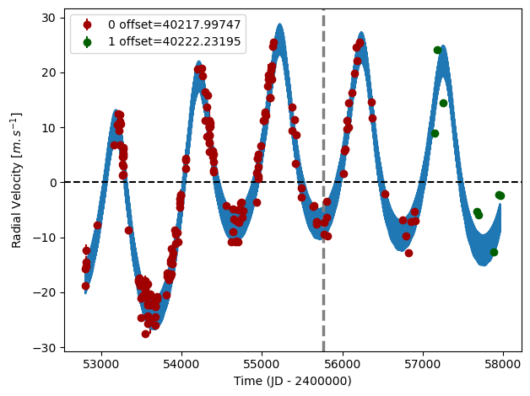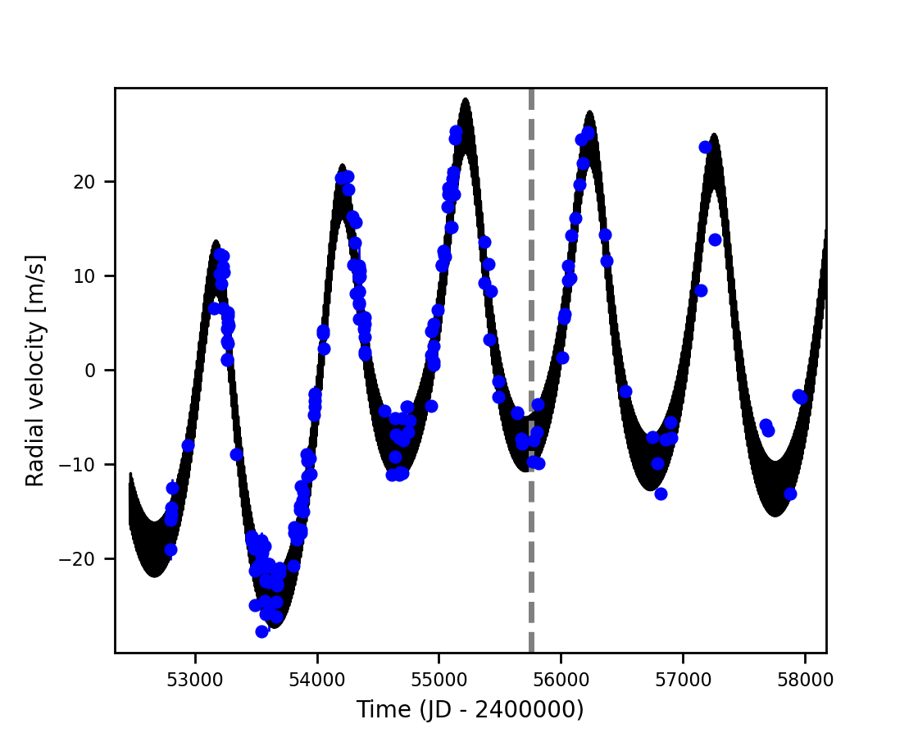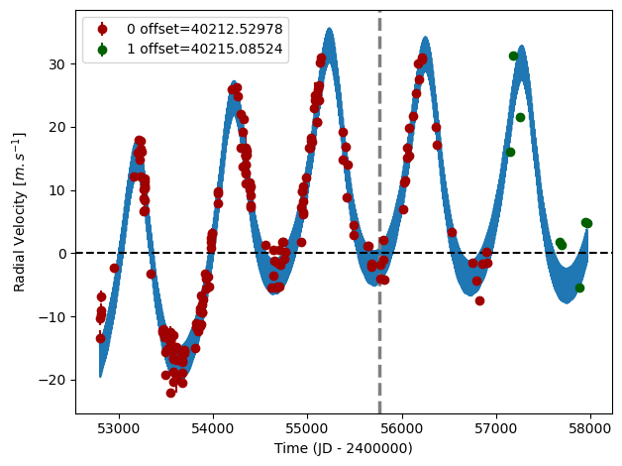

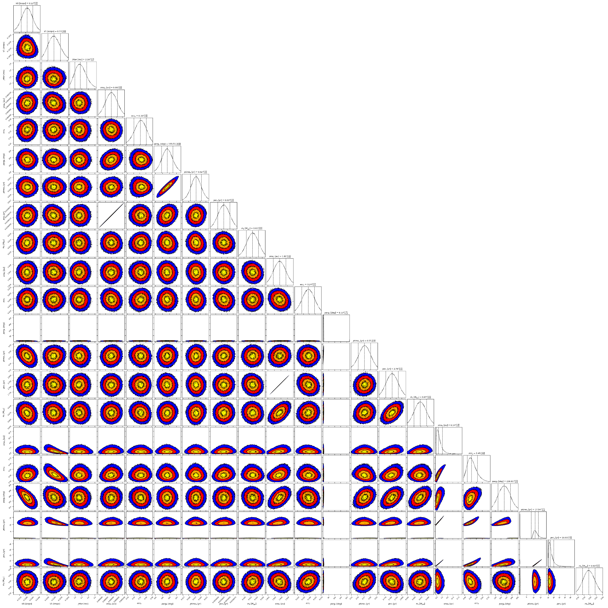

Figure 2: Corner plot of posteriors for the three-planets model MCMC fit of HD 181433 RV data.

| Parameter | Priors | | | Posteriors | | | CH survey |
| --- | --- | --- | --- | --- | --- | --- | --- |
|  | DPASS | | MCMC | DPASS | | MCMC |  |
|  | Free priors | Constrained *a* | Free priors | Free priors | Constrained *a* | Free priors |  |
| *a* (au) | b: [0,0.1]  c: [0,50]  d: [0,50] | b: [0,0.1]  c: [0,5]  d: up to 100 | b: [0.01,0.1]  c: [1.5,2.5]  d: [4,100] | b = 0.08  c = 1.82  d = 6.5 | b = 0.08  c = 1.82  d = 100 | b = 0.080 ± 0.001  c = 1.82 ± 0.01  d = 6.0 – 8.2 | b = 0.08  c = 1.8  d = 3.9 |
| Msin(i) (MJup) | b: [0,0.1]  c: [0,300]  d: [0,100] | b: [0,0.1]  c: [0,10]  d: [0,10] | b: [0.01,0.1]  c: [0.1,1]  d: [0.1,1] | b = 0.02  c = 0.68  d = 0.6 | b = 0.02  c = 0.71  d = 0.91 | b =  c =  d = 0.60 ± 0.02 | b = 0.023  c = 0.7  d = 0.58 |
| Eccentricity | b: [0,0.5]  c: [0,0.95]  d: [0,0.95] | b: [0,0.5]  c: [0,0.95]  d: [0,0.95] | b: [0,0.9]  c: [0,0.4]  d: [0,0.95] | b = 0.35  c = 0.24  d = 0.48 | b = 0.32  c = 0.24  d = 0.95 | b = 0.33 ± 0.09  c = 0.24 ± 0.02  d = | b = 0.42  c = 0.25  d = 0.11 |
| Instrumentals offsets (km/s) | [-100,100] | [-100,100] | [40,41] | H03: 40.218  H15: 40.222 | H03: 40.213  H15: 40.215 | H03: 40.218 ± 0.001  H15: 40.222 ± 0.002 |  |
| Stellar jitter (m/s) | [0,40] | [0,40] | [0,20] | 1.9 | 2.4 | 2.2 ± 0.2 |  |
| Argument of periastron (°) | b: [0,360]  c: [0,360]  d: [0,360] | b: [0,360]  c: [0,360]  d: [0,360] | b: [0,360]  c: [0,360]  d: [0,360] | b = 193  c = 9  d = 239 | b = 201  c = 15  d = 289 | b =  c =  d = 236 ± 10 |  |
| Phase | b: [0,1]  c: [0,1]  d: [0,1] | b: [0,1]  c: [0,1]  d: [0,1] | b: [0,1]  c: [0,1]  d: [0,1] | b = 0.15  c = 0.26  d = 0.88 | b = 0.03  c = 0.14  d = 0.13 | b =  c =  d = 0.98 – 0.09 |  |

Table 1: HD 181433. Summary of priors and posteriors obtained with DPASS and MCMC, compared to the properties reported by the CH Survey.

References

1. Bouchy, F. et al. The HARPS search for southern extra-solar planets. XVII. Super-Earth and Neptune-mass planets in multiple planet systems HD 47 186 and HD 181 433. *Astron. Astrophys.* 496, 527-531 (2009).
2. Horner, J. et al. The HD 181433 Planetary System: Dynamics and a New Orbital Solution. *Astrophys. J.* 158, 100 (2019).